- Firewall Basics Theory

Q.1 Open Windows Defender Firewall settings on your computer and create a new outbound rule to block all traffic from the Spotify desktop app?

Answer

- Blocking Spotify Using Windows Defender Firewall
I opened Windows Defender Firewall with Advanced Security and created a new Outbound Rule for the Spotify desktop application.
I selected Block the connection and applied the rule to all network profiles: Domain, Private, and Public.
- Rule Name: Block Spotify
Direction: Outbound
Action: Block
Status: Enabled

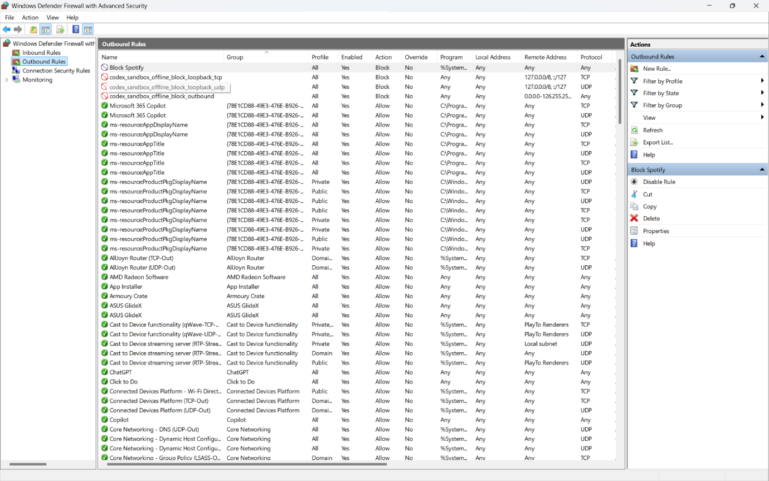
- Result:
The outbound firewall rule was successfully created to block Spotify’s network traffic. The Spotify application can still open, but its internet traffic is blocked by the firewall rule.

Q.2 Set up an inbound rule in Windows Defender Firewall to allow incoming connections only for Google Chrome on port 443 (HTTPS)?

Answer

- Allowing Google Chrome on Port 443
I opened Windows Defender Firewall with Advanced Security and created a new Inbound Rule for Google Chrome.
- The rule was configured with:
- Program: Google Chrome
- Protocol: TCP
- Local Port: 443
- Action: Allow the connection
- Profiles: Domain, Private, and Public

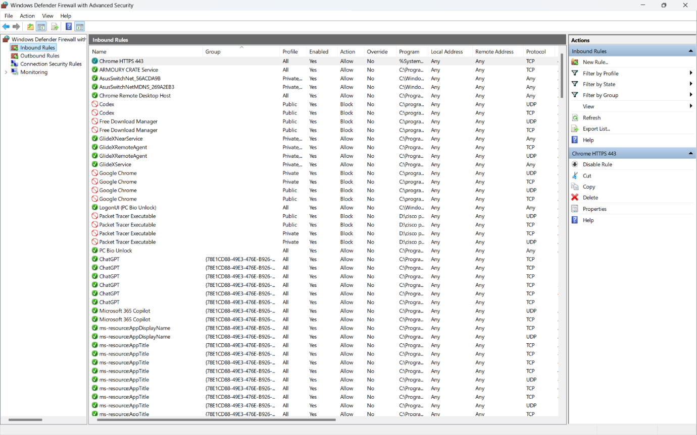

- Result:
The inbound firewall rule was successfully created to allow incoming TCP connections for Google Chrome on port 443.

Q.3 Document, step-by-step, how you would block all traffic from a specific IP address (for example, 123.45.67.89) using Windows Defender Firewall.<br><br><em><strong>Hint:</strong> Use the 'Scope' tab when creating a new rule to specify the IP address.</em>?

Answer

- Blocking Traffic from a Specific IP Address
To block traffic from the IP address 123.45.67.89 using Windows Defender Firewall, I would follow these steps:
- Press Windows + R, type wf.msc, and press Enter.
- Open Inbound Rules.
- Click New Rule.
- Select Custom and click Next.
- Select All programs.
- Keep the protocol type as Any.
- Go to the Scope section.
- Under Remote IP addresses, select These IP addresses.
- Click Add and enter: 123.45.67.89
- Click Next.
- Select Block the connection.
- Apply the rule to Domain, Private, and Public profiles.
- Name the rule: Block 123.45.67.89
- Click Finish.
- Result:
All incoming traffic from the IP address 123.45.67.89 will be blocked.
To block traffic in both directions, I would create the same rule under Outbound Rules as well.

Q.4 Compare hardware firewalls (like those used in large offices) and software firewalls (like Windows Defender) by listing 3 key differences and a use case for each?

Answer

- Hardware Firewall vs Software Firewall

Point | Hardware Firewall | Software Firewall
- Type | A separate physical device | A program installed on a computer
- Protection | Protects many devices on a network | Protects one device
- Performance | Does not use the computer’s resources | Uses some CPU and memory
- Management | Usually managed by a network administrator | Can be managed by the individual user

- Hardware Firewall Use Case:
A large office can use a hardware firewall between the internet and the company network to protect all computers and devices at the same time.

- Software Firewall Use Case:
Windows Defender Firewall can be used on a personal laptop to block unwanted apps, ports, or IP addresses.

- Conclusion:
Hardware firewalls are mainly used to protect entire networks, while software firewalls are used to protect individual computers.

